Card Checking

**OUTPUT**

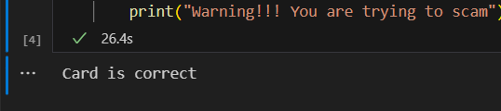

**EXPLANATION**

* I HAVE MAKE THE CODE FOR CHECKING ANY DEBIT CARD NUMBER .
* IN WHICH FIRSTLY REMOVE SPACES AND THEN END DIGIT GIVE TO VARIABLE AND REMOVE FRIM THESE NUMBERS.
* REVERSE THE ORDER ,THEN MULTIPLY TWO IF INDEX NUMBER IS EVEN AND MINUS NINE IF ANSWER OF MULTIPLY GREATER THEN NINE.

IS TOTAL OF NUMBERS AND THEN ADD NUMBER WHICH WAS ASSIGN TO VARIABLE  
NOW DIVIDED BY 10 IF MOD WILL 0 THEN OUE CARD IS VALID OTHER WISE NOT VALID .  
  
TOPIC

REMOVE PUNCTUATIONSOUTPUT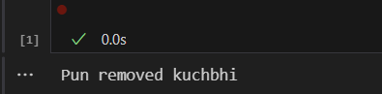 **EXPALANTION** I have make the code in which if any special character come into our sentences ,they will be remove   
only set is_digit if digit then come other charaters will be remove

SORTINGOUTPUT 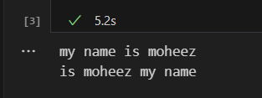  
EXPALANATION

1. make code for bubble sort where I check date the sentence is sorted according to askii code .  
     
   in which we have take variable string   
     
   in which we add the string   
   two loops are used ,for iteration and comparison.
2. in which use split method for separate the strings.
3. First loop is used for itration .

* **Second loop** is **for compare** in which n-1-I so that after each iteration one **comparison** will be lost and other start.
* Have arranges **three variable** and replaces their places .
* Now **,join use** for arranging the word in sequence.